1. **Chassis**

# XIAOR Tracked Tank Chassis

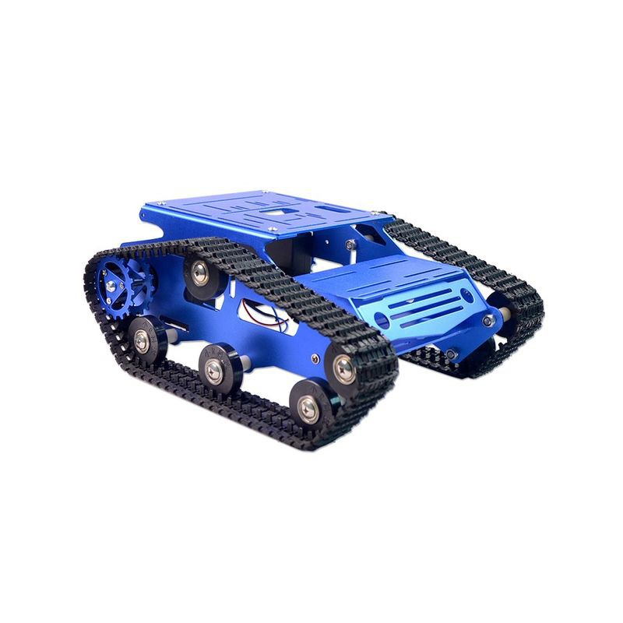

**Source link :** [**https://store.roboticsbd.com/robotics-parts/1264-xiaor-tracked-tank-chassis-diy-robotics-bangladesh.html**](https://store.roboticsbd.com/robotics-parts/1264-xiaor-tracked-tank-chassis-diy-robotics-bangladesh.html)

# Arduino Uno R3

# Arduino Uno R3 (Made in Italy)

# Source Link : <https://store.roboticsbd.com/arduino-bangladesh/94-8-arduino-uno-bangladesh.html>

# JoyStick 5Pin Breakout Module For Arduino

# JoyStick 5Pin Breakout Module For Arduino

# Source link : <https://store.roboticsbd.com/robotics-parts/393-joystick-5pin-breakout-module-for-arduino-robotics-bangladesh.html>

# 12V 10 Amp power supply

# Image result for smps power supply price in bangladesh

# Source Link : <https://www.daraz.com.bd/products/12v-10-amp-power-supply-120w-transformer-12v-10a-led-lighting-switching-power-supply-i115000994-s1032940205.html?spm=a2a0e.searchlistcategory.list.43.3eec4257WFe1jE&search=1>

# L298N H-Bridge Dual Motor Driver, Stepper Motor Driver

# L298N H-Bridge Dual Motor Driver, Stepper Motor Driver

# Source Link : <https://store.roboticsbd.com/motor-driver/376-l298n-h-bridge-dual-motor-driver-stepper-motor-driver-robotics-bangladesh.html>

# DC-DC Boost Module

# Boost Module

# Source Link : <https://store.roboticsbd.com/components/730-xl6009-dc-dc-booster-robotics-bangladesh.html>

# Jumper Wire 40 Pcs Set

**1. Male to Male**

**2. Male to Female**

**3. Female-Female**

**Every type needed**

# Jumper wire 40 Pcs

# Source Link : <https://store.roboticsbd.com/robotics-parts/31-3-jumper-wire-arduino-bangladesh.html#/1-jumper_wire_type-male_to_male>

# Glue Gun

# [Glue Gun](https://store.roboticsbd.com/tools-accessories/834-glue-gun-robotics-bangladesh.html)

# Source Link : <https://store.roboticsbd.com/tools-accessories/834-glue-gun-robotics-bangladesh.html>

# Glue Gun Stick

# 10 pices

# [Glue Gun Stick](https://store.roboticsbd.com/tools-accessories/835-glue-gun-stick-robotics-bangladesh.html)

# Source Link : <https://store.roboticsbd.com/tools-accessories/835-glue-gun-stick-robotics-bangladesh.html>